COS 214 Project

Project Summary and Reports

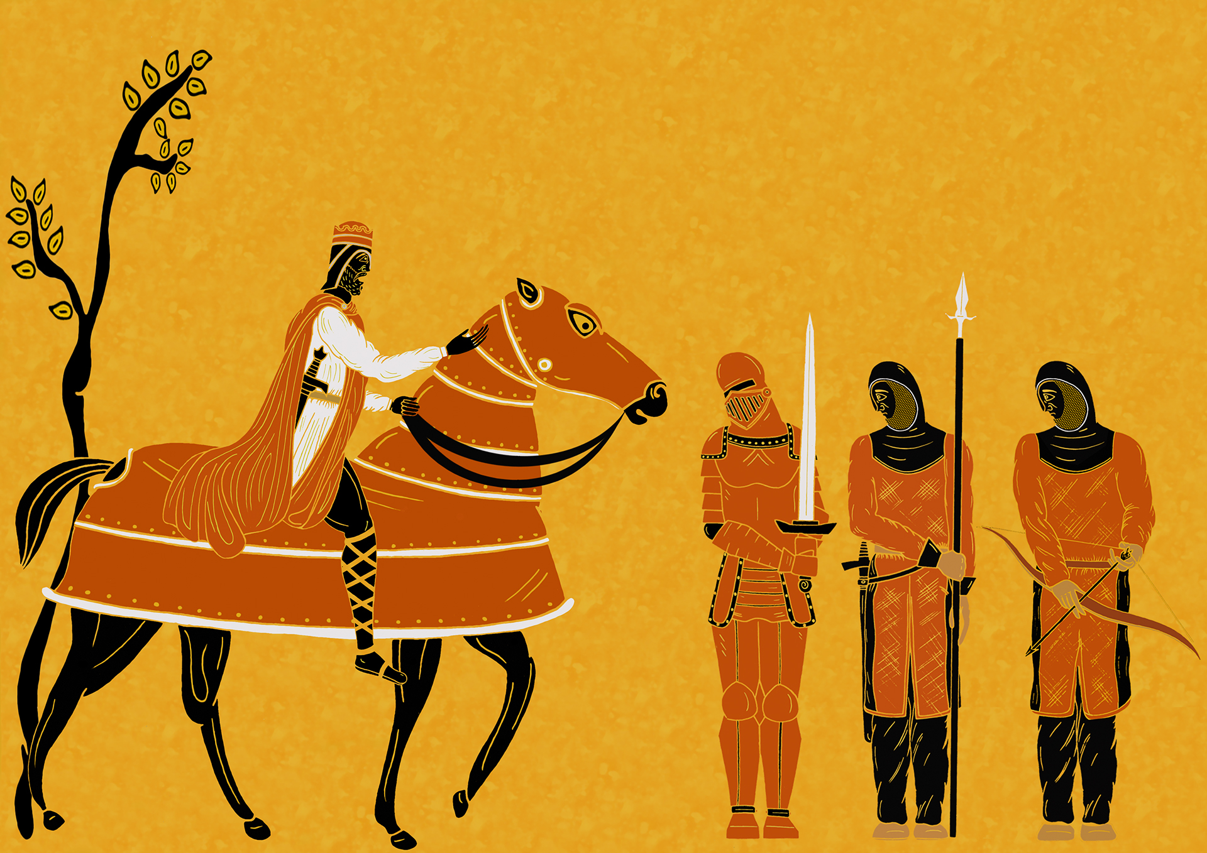

**Julianna Venter, u20433752 (Team Leader)**

**Ronin Brookes, u19069686**

**Sameet Keshav, u21479373**

**Keabetswe Mothapo, u21543462**

**Morgan Bentley, u18103007**

**Thapelo Thoka, u21499749**

# Task 1: Pre-initial design

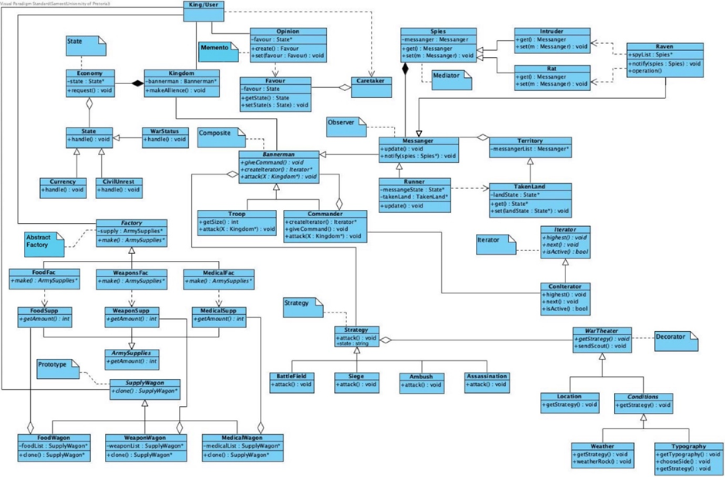

# Task 2:

# Functional Requirements:

* Two bannermen lists must be created
* A user must be able to choose to attack
* If a user doesn’t attack they are forced to yield and lose the war
* If the user attacks they must be able to pick their attacking Bannerman
* If a user attacks they must be able to pick who they are attacking
* A user must be able to choose their attack strategy
* A user will win or lose their war based on a mix of choices and random chance
* A user must be able to choose to send for supplies if their bannerman survives the battle
* A user will win the battle if the enemy bannermen are all dead
* A user will lose the battle if their bannermen are all dead, or they run out of money

# Activity Diagrams:

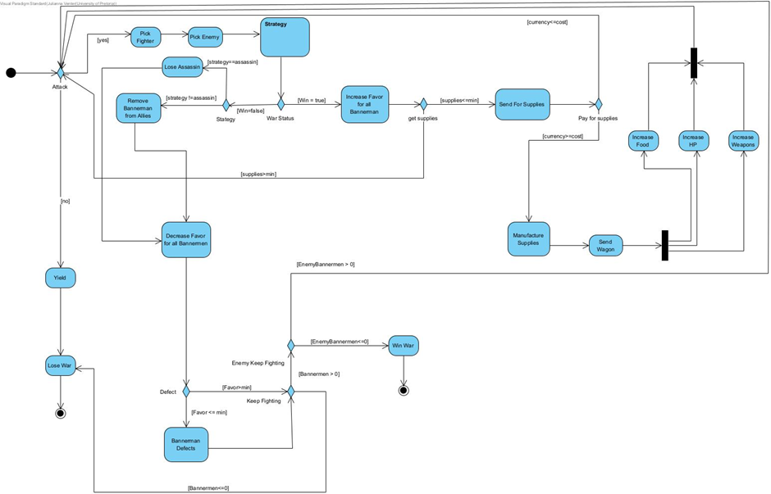

Activity diagram for the main functionality from the user’s perspective.

# 

# 

Activity diagram for the strategy classes.

# Patterns:

## 1. Memento:

Saving the states of defected allies, and restoring the ones who return.

## 2. State:

State of the kingdom’s economy and upkeep during the war.

## 3. Abstract Factory:

Manufacturing of food, weaponry, and medical supplies.

## 4. Prototype:

Supply wagons comprising food, weaponry and medical supplies. To be cloned and sent out when a successful troop returns from a battle.

## 5. Mediator:

Checking if the economy is healthy enough to support further warfare.

## 6. Observer:

Checks if supplies are needed for troops, sends for a supply wagon if needed.

## 7. Strategy:

Different types of battle to choose from when engaging the enemy.

## 8. Composite:

Comprises the Bannermen (allied kingdoms), the troops and commanders of these allies.

## 9. Iterator:

Controls line of command in troops.

## 10. Decorator:

Controls and generates war theater, influencing outcome of battle.

# Class diagrams:

# Initial Design:

# Sequence Diagrams:

# Communication Diagrams:

# State Diagrams:

# 

# Object Diagrams:

# Task 3:

Implementation included in files.

# Task 4:

## Research Report:

The core theme of our war engine revolves around medieval warfare, as it provides more flexibility and creativity to apply the design patterns.

Our war simulation follows the monarch of the kingdom Dura (the user), who must make decisions throughout the war to defeat the United Kingdoms of Preadora. Our kingdom has five bannermen (Countries in Country groups allied to ours), who must individually fight five other bannermen of the enemy kingdom in order to take over their land.

Our simulation uses various elements to influence the outcome of the war. Each bannerman within the country is influenced by favor, which is increased or decreased depending on the outcome of a battle. This favor is then used to decide whether the bannerman defects from the allies and joins the enemies, or remains faithful to the allies. This bannerman may later decide to return to the alliance. The success of the war depends on how many bannermen remain standing, the kingdom’s economy (money for supplies to support troops, the state of the civil population, etc).

In warfare, it is evident that hierarchy is crucial. Certain decisions are taken at different authority levels. We embodied this by implementing our own pyramid of command: the monarch (user) is in command of every bannerman in the kingdom, these bannermen each have troops that are assigned a commander.

The battles themselves are influenced by the war theaters , which have their own advantages and disadvantages. These include the landscape, climate & weather, time of day, length of the battle in that specific theater, and most importantly, the use of these facts to plan the attack or defense.

In many notable battles in history, weather has played a key role in the outcome of that battle. Conditions such as heavy snowfall easily stopped soldiers in their tracks (i.e. Napoleon and Hitler’s attempt to invade Russia) or heavy winds working in the favor of other’s (Winds carrying flames over the Spanish Armada fleet).

Our war simulator uses topology and weather to similarly determine if any advantages and disadvantages will be added to the battle.

(Thomas, D. , *7 Times Weather Affected War*, 03/03/22)

https://www.foxweather.com/learn/7-times-weather-affected-war

*“...the scale of war a thousand years ago appears small, but the share of resources that was consumed by war was enormous. This consumption included not only the expenses of waging war but, almost invariably, the deliberate destruction of economic assets that accompanied invasions, and sometimes retreats as well.”* ***- Jurgen Brauer & Hubert van Tuyll***

War has a great impact on the economic state of a kingdom. There is great cost in keeping - not only the people of the kingdom - but the soldiers, fed and armed. Moreover, medical aid and housing supplies add to these expenses.

Our simulation takes this into consideration when planning attacks. War is quickly lost if no supplies are being sent out to troops and food runs scarce within the kingdom. This can make the bannermen lose favor, which will result in the loss of more and more allies until the war is lost. Similarly, if the costs have been well regulated and supplies sent out strategically, the war victory is yours.

(Brauer, J., van Tuyll, H.,*Castles, Battles, and Bombs: How Economics Explains Military History*, 2008)

https://press.uchicago.edu/Misc/Chicago/071633.html

Beyond battles in fields, war is carried out in different events. Strategic decisions and actions are taken with the pure motivation of the war. These events include castle and fortress sieges, assassinations of influential parties and troop campsite ambushes.

Our simulation makes use of these strategies to give the user more flexibility in decision-making to gain the best outcome in the war. Different strategies have different effects on troops, supplies, likelihood of success and bannerman favor. For instance: sending an assassination spares your troops and supplies, but is a lot riskier since the chances of success are lower based on stealth.

(Swansea University, *WARFARE IN WESTERN EUROPE IN THE CENTRAL MIDDLE AGES)*

https://www.swansea.ac.uk/history/history-study-guides/warfare-in-western-europe-in-the-central-middle-ages/

Through these elements and entities our user has many factors to keep in mind throughout the stages of the war and, consequently, their discernment will determine the victorious kingdom.

## Design Report:

# Task 5:

* Git used and information included in submission readme.txt
* Doxygen used and information included
* Unit testing included

# Task 6:

The following images represent an instance of the simulator upon running the program:

Notes for group:

* Add your diagram + small description
* Do we need to meet those Components of War points in the spec? (ask mentor)
* If yes: does it need to be code or is the design report sufficient?
* Reports separate?
* What is Launch Reenactment? (ask mentor)
* Bannerman: name attribute, getName() function, make constructor taking in all initial attributes, (name, favor, supplies etc) @Thapelo
* Deadline for pattern code + reports: 31 October
* Deadline for final code: 5 November
* Final group meeting: 6 November (have all documentation done)
* Submission: 8 November

Management

Basic outline of work distribution and internal deadlines.

# Task 1:

Whole group contributed.

Deadline: 3 October - met

# Task 2:

Functional requirements: Group contributions

Activity Diagrams: Julianna Venter

Patterns: group contributions

Class diagrams: Sameet Keshav

Sequence/Communications diagrams: Ronin Brookes

State Diagrams: Morgan Bentley

Object Diagrams: Thapelo Thoka

Deadline: 18 October - met

# Task 3:

1. Memento: Julianna Venter

2. State: Morgan Bentley

3. Abstract Factory: Ronin Brookes

4. Prototype: Ronin Brookes

5. Mediator: Sameet Keshav

6. Observer: Sameet Keshav

7. Strategy: Morgan Bentley

8. Composite: Thapelo Thoka

9. Iterator: Thapelo Thoka

10. Decorator: Keabetswe Mothapo

Testing and updates: Keabetswe Mothapo

Main functionality and simulation: Julianna Venter

Deadline: 31 October

# Task 4:

Research report: Julianna Venter & Keabetswe Mothapo

Design report: Ronin Brookes & Thapelo Thoka

Deadline: 31 October

# Task 5:

Github management: Sameet Keshav

Doxygen management: Morgan Bentley

Deadline: 6 November